**Android Lab – Rotation, Saved Instance State, and ViewModel**

**1. SeekBar app with portrait and landscape layouts**

Verify that you have the SeekBar app running correctly. The TextView should display the current progress of the SeekBar. Your app should a different layout for portrait and for landscape orientations. Both layouts should have the same components but arranged differently.

**Paste a screenshot of your app in landscape orientation, and a screenshot of your app in portrait orientation.**

**Push your app project code to GitHub and paste a link to your repository here**

**2. Guest List app, View Model and Saved Instance State**

Verify that you have the Guest List app running correctly, including the clear button.

Check that names are added to the list correctly, and that the list of names is preserved when the device or emulator is rotated.

Your app should have a landscape layout.

**Paste some screenshots of your app running, including at least one screenshot in each orientation.**

**Push your app project code to GitHub and paste a link to your repository here**

**3. Survey App with Rotation**

Start a new app.

Imagine you are surveying MCTC students with a simple question with a Yes/No answer. For example,

* Does pineapple belong on pizza?
* Are the Vikings going to win the Superbowl?
* Can you do a handstand?
* Would you like to go to space?

You may use another question with two answers if you prefer.

Create a main Activity that shows your survey question in a TextView.

Add two buttons, one for Yes and one for No (or appropriate answers to your question.)

Add two TextView components, one to show the total Yes votes, and one to show the total No votes.

As you survey students, every time you ask someone the question and they answer 'yes', you can tap the Yes button to add 1 to the Yes total. And if someone answers 'no', you can tap the No button, and this should add 1 to the no total. The yes and no TextViews should update as you collect votes.

Add a reset button to reset the totals to zero.

Make sure the total votes for Yes and No are saved when the device is rotated. **Use a ViewModel.**

An example layout is shown below with 16 yes votes and 17 no votes. If the reset button was tapped, both counts should reset to 0. Then, if the yes button was tapped, the yes count is set to 1.

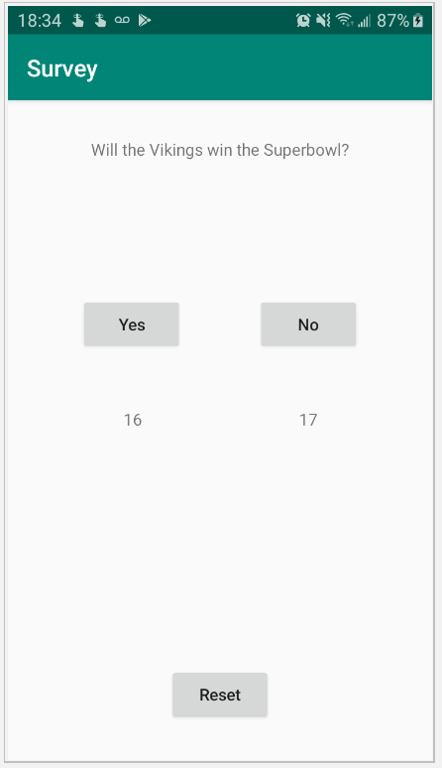

***Optional:*** Add a landscape layout to this app.

**Paste some screenshots of your app running.**

**Push your app project code to GitHub and paste a link to your repository here**

**4. Big Nerd Ranch GeoQuiz**

Follow Chapters 3, 4, and 5 to continue building the GeoQuiz app.

**Paste some screenshots of your app running.**

**Push your app project code to GitHub and paste a link to your repository here**